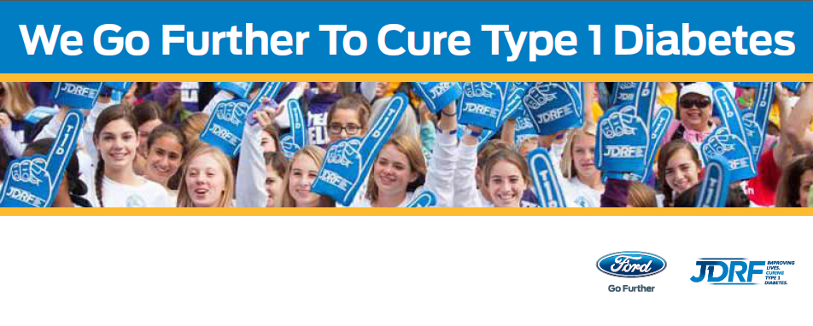

2014 Ford Wisconsin Family Team Sponsorship Application
Application Information Please type or print clearly & use additional paper if needed.
- Please submit your application to JDRF no later than Monday, June 16, 2014
- Only currently REGISTERED Walk teams will be considered for the program
- Attach information to support your team application such as your Family Team letter and photos
- Dealership sponsorship will count toward your team’s total
- Team selection is by Ford Dealership and dependent on number of participating dealers; unfortunately, not all
applicants will be selected
NEW THIS YEAR! FORD $500 DONATION
Teams not paired with a dealership will be entered into a drawing TO WIN ONE $500 Team donation.
Walk Team Information
Team Name _______________________________ Team Captain _______________________________________________
Address_____________________________________________City_____________________State______Zip____________
Home Phone ________________________Mobile ____________________ Email__________________________________
Walk Site__________________________ # Years Walking___________
Previously sponsored by a Ford Dealership? Yes _____No______
Previous Sponsor Dealership Name________________________________________________________________________
Tell Us About Your Team!
Why do you Walk?
How would you and your team use social media to highlight your Ford Dealership support?
How do you envision your team and a Ford Dealership working together?

Please direct questions and your application to Megan Gavin, Regional Walk Manager: 312.515-6647 or mgavin@jdrf.org

